# **Brief History on the big three: HTML5, CSS & JavaScript**

Twenty eight years ago today, a proposal was sent internally at CERN outlying a universal linked information system. Dubbed 'Information Management: A proposal', pictured below, the proposal was created by Sir Tim Berners-Lee and was sent to his boss Mike Sendall, who described it as 'vague but exciting'.

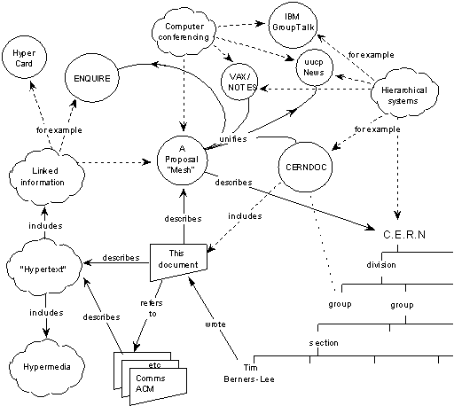

Sir Tim Berners-Lee’s vision for universality enabled the development of a high-level network of content that allows any document to link to any other documents.

The World Wide Web was initially created to make it easier to share research papers. It is a system of interlinked ‘hypertext’ documents that are accessed via the Internet; in essence, an information space. While he did not invent hypertext systems, Berners-Lee proposed using them 'to link and access information of various kinds as a web of nodes in which the user can browse at will.'

His breakthrough was to link hypertext to the Internet and he used three technologies to do this:

* HyperText Transfer Protocol (HTTP) is the foundation of data communication for the Web.
* HyperText Markup Language (HTML) is the main mark-up language for creating Web pages and information that can be displayed on a Web browser.
* Web addresses or a Uniform Resource Locator (URL) are used to reference a Web page.

## **HTML5:**

When people say 'HTML5', they usually mean a bit more than just the 5th version of the "HyperText Markup Language". Modern Web pages and Web applications are generally composed of at least three components, so what people often mean when they say 'HTML5' is the trio of languages: HTML5, CSS3 and JavaScript.

The 'HTML' part contains all the content, organized into a logical structure. This is the part that an author might be most concerned with: the words, chapter headings, figures, diagrams, etc.

While there have been numerous versions of HTML since its inception, our focus in this course is the most recent version, HTML5. HTML5 was developed to provide more powerful and flexible ways for developers to create dynamic Web pages.

## **CSS:**

The 'CSS' part (version 3 being current) is all about the presentation or style of the page; what it looks like without too much regard for the specific content. We'll be going into more detail on that later in this course, but for now, think of it as the way you might specify a "theme" in a word processing document, setting fonts, sizes, indentations and whatever else may apply to what it looks like.

## **JavaScript:**

The 'JavaScript', or 'JS' for short, part is about the actions a page can take such as interaction with the user, and customizing and changing the page according to any number of parameters. This is what allows a Web page to be more than just a document, but potentially a Web application, with nearly unlimited possibilities. We will not be doing much with JavaScript in this course, but you should know that it is an important leg of the stool for modern Web pages.

## **Hypertext:**

A fundamental key to the World Wide Web is the concept of "*Hypertext*". Hypertext is built on the idea of linking information together, not unlike using footnotes, except much easier and more flexible. The idea was to "Mark Up" your document with links and define how to break it down into different segments (chapters, sections, paragraphs, tables, figures, etc.)

That's why, in 1989, Tim Berners-Lee began to create a definition of HTML: Hypertext Markup Language, to provide a simple, uniform way to incorporate Hyperlinks in a text document.

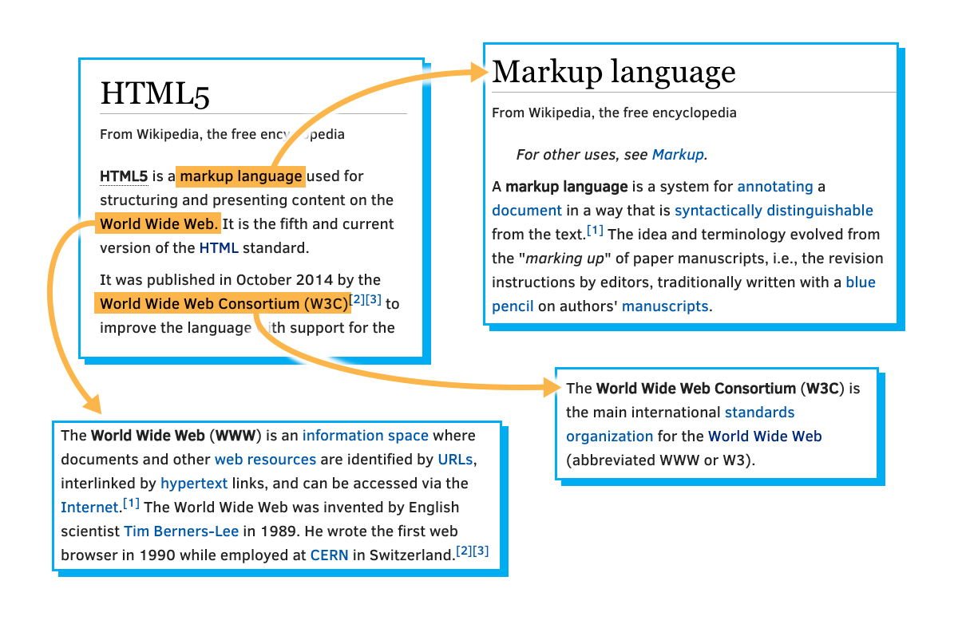

He envisioned a technology that would facilitate thoroughly interconnected documents. He wanted authors to be able to connect an idea in one document to the source of the idea in another, or connect a statement with the data that backs up that statement. Traditionally, this kind of thing was done with footnotes and bibliographies, which can be cumbersome. This information should be easily transferable from one place to another, so that in reading one document, it is easy to access everything related (linked) to it. Tim Berners-Lee imagined a "Web" of interconnected documents.

He used the metaphor of a Web to emphasize the importance of connections between documents. It was not just a long list of details, but rather a sea of information stretching out in all directions. This sea of information was navigated by a new tool called a "Browser".

## **The Browser:**

The Internet existed long before the Web came to fruition, and lots of organizations were connected to it, including schools, companies and government organizations. As things progressed through the 80s, the Internet was used for file transfers, newsgroups (a kind of open forum), email and other conveniences.

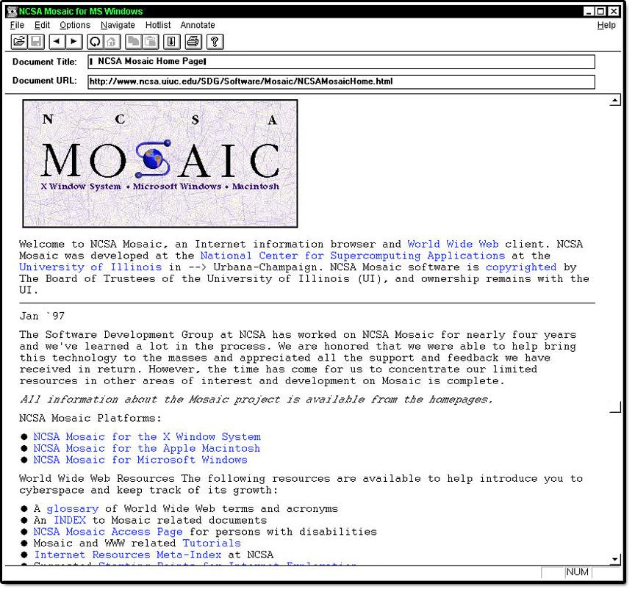

At the time there were a number of different programs like '[fetch](https://en.wikipedia.org/wiki/Fetch_(FTP_client))', '[gopher](http://www.yourdictionary.com/gopher#Noun-3)' and '[archie](https://en.wikipedia.org/wiki/Archie_search_engine)' that were used to download, browse and search for files. Typically, you might use one tool to search for the location of files of interest, then another to copy that file to a local machine. Then, you still needed more tools to read that file. If it was text, you could use a text editor, if it was a formatted document you might need a word processor, if a picture you would need an image viewer and so on.

[Marc Andreessen](https://en.wikipedia.org/wiki/Marc_Andreessen) conceived of a solution that would put all the pieces together in one app, making it easy for users to browse all the different sorts of information and data on the World Wide Web. Together with others, he started the "Mosaic" project.

Though not technically the first browser, Mosaic was the first one that many people experienced and played a big part in popularizing the concepts of the World Wide Web and the Web browser. It provided a simple graphical way to access and browse the various resources on the Internet. Instead of using different tools to download and view information on the Internet, a simple click on a link would present the information in a graphical window. In many ways, it is the ancestor of most modern browsers.